< Thesis Title>
<Bachelor Thesis/Master Thesis >
to be awarded
<B.Sc./M.Sc.> in Economics
submitted by
<First name, last name>
<DD.MM.JJJJ>

<First name, Last name>
<E-mail-address>
Address:
<Street, Number>
< ZIP code, City>

Supervisor
1. <First supervisor>
2. <Second supervisor, if applicable>

Friedrich Schiller University Jena
Faculty of Economics
Chair of Economic Policy
Carl-Zeiß-Straße 3
07743 Jena
Abstract
Short summary of the thesis (max. 250 words) ...
Acknowledgment
If you want to thank someone (optional)...
Table of Content
List of Figures iv
List of Tables v
List of Acronyms vi
1 Introduction 1
2 First Section 2
2.1 First Subsection of the First Section 2
2.1.1 Sub-subsections, if Applicable 2
2.2 Second Subsection of the First Section 2
3 Second Section 3
3.1 First Subsection of the Second Section 3
3.2 Second Subsection of the Second Section 3
3.3 Last Subsection of the Second Section 4
4 Conclusion 5
Bibliography 6
Appendix 7

List of Figures
Figure 1: Pasteur's Quadrant 3

List of Tables
Table 1: GDP per capita 3

List of Acronyms
GDP Gross Domestic Product
FSU Jena Friedrich Schiller University Jena

Introduction
Here begins the introduction of your thesis. You are almost there!

First Section
Here you can insert a small section introduction if necessary. Automatic hyphenation is activated.

First Subsection of the First Section
How you structure your respective sections is up to you. However, make sure that it makes sense!

Sub-subsections, if Applicable
...

Second Subsection of the First Section
Your text. Here you can cite Nelson (1959) or list a citation that involves multiple individuals (e.g., Nelson and Winter, 1982; Dosi, 1982; Lundvall, 1992; Acemoglu, 2002). You can also refer to a section 2.1 in which you previously introduced important concepts, definitions, etc.

Second Section

First Subsection of the Second Section
Here you refer to e.g. Table 1. In Figure 1, one can see…
Table 1: GDP per capita
Country | GDP per capita
Qatar | 132,099
Luxembourg | 98,987
Singapore | 85,253
Source: International Monetary Fund (2015)

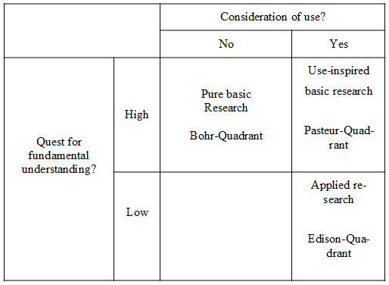
Figure 1: Pasteur's Quadrant
Source: Donald E. Stokes, Pasteur's Quadrant. Basic Science and Technological Innovation, Brookings Institution Press, 1997.

Second Subsection of the Second Section
If you want to insert formulas, you can put them inside the text $y=x_{1}^{0,5}x_{2}^{0,5}$, or centered like here
$$y=x_{1}^{0,5}x_{2}^{0,5}$$
or numbered
 | $$y=x_{1}^{0,5}x_{2}^{0,5}$$ | (1)
so that you can refer to equation (1) in the text.

Last Subsection of the Second Section
Here would be space for a smaller summary of their findings before you draw their final conclusion.

Conclusion
This is where your conclusion begins.

Bibliography
Last name, first name (year of publication). Title: subtitle, if any. Journal name, volume (number): p. X - Y.
Last name, first name (year of publication). Title: subtitle, if any. Publisher. Place of publication.
Last name, first name (year of publication). Title: subtitle, if any. In: last name, first name (ed.), if applicable. Title of the volume/series (number, if applicable): p. X - Y.

Appendix
If you want to attach additional material, such as detailed descriptions of your data collection, tables or figures...
Statutory Declaration:
I declare that I have developed and written the enclosed <Bachelor Thesis/Master Thesis> completely by myself, and have not used sources or means without declaration in the text. Any thoughts from others or literal quotations are clearly marked. The <Bachelor Thesis/Master Thesis> was not used in the same or in a similar version to achieve an academic grading or is being published elsewhere.

________________________ ______________________
City, Date Signature

